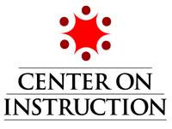

MODULE 2: INFORMATIONAL TEXT STRUCTURE:
USING KNOWLEDGE OF TEXT STRUCTURE TO IMPROVE COMPREHENSION IN GRADES 6-12
TRANSCRIPT

SLIDE 1

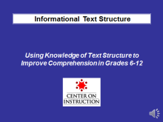
Hello everyone and welcome! Thank you for joining the Center on Instruction’s module on Informational Text Structure: Using Knowledge of Text Structure to Improve Comprehension in Grades 6-12.

This is one of two professional development modules on informational text structure instruction. The other module focuses on text structure instruction for students in kindergarten through grade 5.

This module is predicated on the assumption that students in the upper grade levels have already had initial instruction in the five basic text structures and some experience in using text structure knowledge to help them comprehend informational text. If you teach adolescents who lack background knowledge about informational text structure or experience in using it to improve their comprehension, you may wish to watch the K-5 module in addition to this one.

Some of the sections and handouts are the same in both modules, since the definitions, general research findings, key strategies and other instructional considerations apply to all grade levels.

Both modules are designed to provide key principles and practices that support classroom literacy instruction. Each module provides resources useful to educators working to improve literacy instruction, as well as technical assistance providers and others interested in school improvement.

In this module, I will refer to handouts that can be downloaded with the module. When I refer to a handout, feel free to pause this presentation to locate it. You may also wish to refer to the document Module 2 Handouts, Resources, and References for a complete list of all handouts provided as well as other resources that can support your understanding of this topic and references we used to develop this module.

My name is Vicki LaRock. I am from RMC Research Corporation and serve as a reading content specialist with the Center on Instruction’s Literacy Team. I will be presenting this module on Using Knowledge of Text Structure to Improve Comprehension in Grades 6-12.

Slide 2

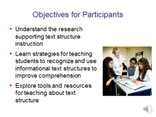
It is important to start with the participant goals for this module. The objectives include:
- understanding the research that supports instruction in informational text structures,
- learning about key instructional strategies that help students recognize various text structures and use that knowledge to improve their comprehension, and
- exploring tools and resources to help plan and deliver effective text structure instruction.

While it is important to acknowledge that teaching about text structure applies to both narrative and informational text, and that the research supports direct, explicit instruction in both, this module focuses only on informational text for two reasons:

- Students in the elementary grades generally have had more exposure to narrative text than informational text. So, when they reach the upper grade levels, they may be less adept at identifying informational text structures and using that knowledge to improve their comprehension than they are at applying story structure knowledge.
- The Common Core and other college- and career-ready standards have placed an increased emphasis on reading informational text. In order for students to meet these new standards, teachers in all content areas must provide them with the tools and strategies they need to comprehend increasingly complex informational texts. Text structure use is one of those tools.

Slide 3

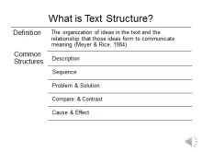
Since participants viewing this module may have varying degrees of familiarity with text structure, let’s start by defining it. There are a surprising number of different definitions of text structure in the literature. The definition on this slide seems to capture the essence of what text structure is and its connection to comprehension.

Text structure refers to the organization of ideas in a text and the relationship that those ideas form in order to convey meaning.

The five most common informational text structures that students encounter in their reading are description, sequence or chronology, problem-solution, compare and contrast, and cause and effect.

There are additional text structures that can be introduced and studied in the upper grade levels once students master and consistently use knowledge of the basic structures to improve their comprehension. These would include proposition-support, judgment/critique, and inductive/deductive. Although this module will focus on building student knowledge of the five common structures, the strategies for providing direct, explicit text structure instruction would apply to teaching other informational text structures as well.

Slide 4

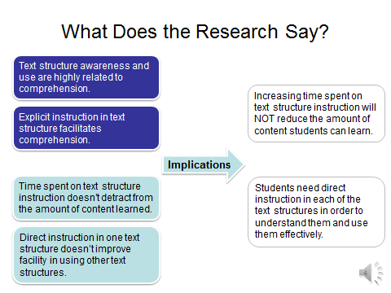
Over the last 25 years, research studies on text structure have consistently shown that teaching students about the organization of text, or text structure, has a positive effect on comprehension and that awareness of text structure is one hallmark of a good reader.

The convergence of evidence from individual studies and at least one meta-analysis suggests that:
- text structure awareness and use are highly related to comprehension; and
- direct, explicit instruction in text structure facilitates comprehension.

Multiple studies have also confirmed two other findings that are important to keep in mind as we think about the role of text structure instruction in improving comprehension:
- spending time on text structure instruction does not negatively impact the amount of content learned; and
- direct instruction in one type of text structure does not improve a student’s ability to use other text structure types in comprehending text.

Two classroom implications for these findings are that:
- increasing the time teachers spend on text structure instruction will not reduce the amount of content students can learn, which is particularly important for middle and high school content area teachers to know; and
- students need direct instruction in each of the text structures in order to understand them and use them effectively to improve comprehension.

Slide 5

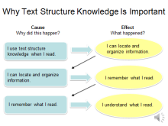
We know that research has clearly indicated that text structure awareness and use has a positive impact on comprehension. I’ve summarized some of the common findings from the research into a cause and effect chain explaining why learning about text structure and applying that knowledge is so important to comprehension.

This graphic organizer could be used as a tool for explaining to students why using text structure is important in helping them become better readers. You might explain it to students this way:

Because I used my knowledge about text structure when I read this assignment, that helped me locate and organize the information. Because I was able to find and organize that information, I could remember it better. And because I was able to remember more of what I read, it was easier to understand it.

Comprehension of grade level informational text is a keystone of rigorous college- and career-ready literacy standards such as those exemplified in the Common Core State Standards.

Slide 6

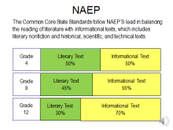
The Common Core State Standards are aligned with the National Assessment of Educational Progress (NAEP) reading test framework, which uses this distribution of literary to informational text. It begins with a 50-50 balance between the two at the elementary level and increases the emphasis on informational text through the grade levels, calling for 55% of the texts students read in middle school and 70% of the texts students read in high school to be informational.

This is sometimes misunderstood to be the percentage of fiction versus non-fiction, or expository text. It is important to keep in mind that Informational Text is an umbrella term that includes literary nonfiction like biographies and autobiographies; books about history, social studies, science, the arts, and technical subjects; information displayed in graphs, charts and maps; and digital sources.

The second common misunderstanding about these percentages is that they apply to what is read in English language arts classes. The percentages of informational text in these charts reflect the total sum of student reading across the grade that should be informational, which would include texts read in all disciplines.

This increased focus on reading informational text will require teachers in all content areas to provide explicit, direct instruction in how to read the informational text required in their disciplines. Teaching students strategies for using text structure knowledge to organize, remember, and understand information will be key in helping students meet the literacy demands of college- and career-level texts.

Let’s briefly review how the Common Core reading standards are organized and look at some of the Common Core State Standards for which informational text structure knowledge plays a critical role in ensuring students’ college and career readiness.

Slide 7

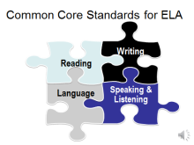
The Common Core State Standards for English Language Arts, which have been adopted by most states, are divided into four inter-related strands: Reading, Writing, Speaking and Listening, and Language.

Slide 8

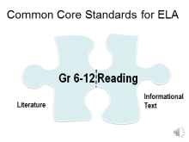
Although there is a single set of College and Career Readiness Anchor Standards for Reading across all grade levels, there are two separate subsets of grade-specific reading standards for 6 through 12 English Language Arts: one for Literature and one for Informational Text.

Comparing the two makes it clear that the knowledge and skills required to be successful readers of literature are different from those required to be successful readers of informational text. Although we won’t take time to do that during this module, engaging teachers in a comparison of the two subsets of reading standards would be valuable professional development to help teachers understand the differences.

Slide 9

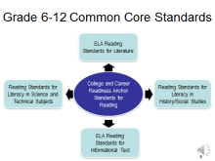
The College and Career Readiness Anchor Standards for Reading that are the basis for the grade-specific English Language Arts standards for Literature and Informational Text also serve as the anchor standards for the Reading Standards for Literacy in History/Social Studies and the Reading Standards for Literacy in Science and Technical Subjects for grades 6-12.

Slide 10

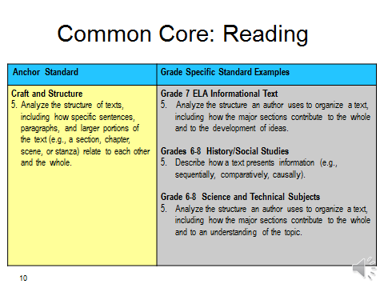
The Common Core State Standard that most explicitly addresses text structure knowledge is Reading Anchor Standard 5 on the left of this chart. The corresponding grade or grade-band specific standards for English Language Arts Informational Text, Literacy in History/Social Studies, and Literacy in Science and Technical Subjects are listed on the right. As you can see there are different expectations for what students need to know and do in order to meet the anchor standards in each of the disciplines. The grade specific standards for ELA Informational Text and for Literacy in Science and Technical subjects are very similar, requiring students to analyze the organizational structure of a text. In History/Social Studies, students are expected to describe how a text presents information.

Engaging teachers in comparison activities like this one, with extended discussions about what they find, would be valuable professional development. Such activities can help teachers in all content areas learn about and implement the new standards collaboratively, using the interdisciplinary approach to literacy development that is a key design feature of the Common Core.

Slide 11

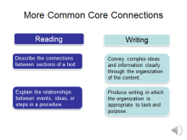
Even though this module takes only a snapshot look at one reading anchor standard that addresses informational text structure, it is important to note that students are expected to meet other reading standards that also require knowledge of informational text structures, such as describing the connections between sections of a text and explaining the relationships between events, ideas, or steps in a procedure.

Furthermore, knowledge of informational text structure is also referenced in the writing standards. The College and Career Readiness Anchor Standards for Writing require students to convey complex ideas and information clearly through the organization of the content and to produce writing in which the organization is appropriate to task and purpose.

Slide 12

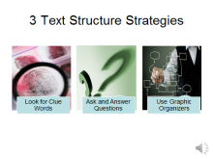
Given that the research supports teaching about text structure knowledge to improve comprehension, and that applying text structure knowledge is an expectation of college- and career-ready standards, how do teachers in grades 6-12 support text structure awareness and use?

There are three key research-based strategies students should be taught in order to recognize text structure and use that information to improve comprehension. They are:
- looking for clue (or signal) words that help identify the text structure;
- learning a few generic questions to ask and answer for each structure during or after reading; and
- using graphic organizers to help find, organize, and remember the content.

The remainder of our time will be spent learning about these strategies and what effective text structure instruction looks like in grade 6-12 classrooms, practicing some of what we learn, and becoming familiar with some resources designed to support informational text structure instruction.

First, let’s orient ourselves to these three strategies as they apply to each text structure by looking at Handout #1.

Slide 13

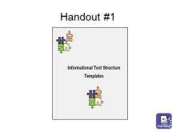
Handout #1, Informational Text Structure Templates, contains a one-page information sheet on each of the five common structures found in informational text. The template for each text structure type includes the purpose, a listing of signal words and phrases often associated with that text structure, examples of key questions to ask and answer while reading passages written in that text structure, and sample graphic organizers that lend themselves to that text structure.

The templates were designed to span multiple grade levels, and their purpose is two-fold. First, teachers can use them as an aid when planning text structure lessons. Second, teachers can adapt them for student or classroom use by selecting signal words, comprehension question frames, and graphic organizer examples appropriate for their grade level and content.

Let’s use the Cause and Effect template on Page 5 of this handout to talk about the three key strategies students must apply in order to use text structure as a way to understand informational text. Cause and effect is often the structure that is hardest for readers to understand.

Slide 14

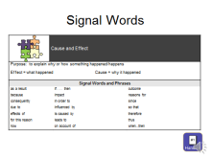
The first step towards using text structure to improve comprehension is to identify the general organizational structure of the passage. To do that, students are taught to look for signal words and phrases that might provide clues to the type of structure the author used. For example, words like “because” and “therefore” and phrases like “as a result of” or “for this reason” are often indicators of the Cause and Effect text structure.

Slide 15

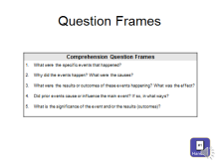
Once students have determined the overall structure of the passage, they can select comprehension questions to ask themselves or others, and answer as they read. This will help them identify the important information the author wants the reader to understand and remember.

Slide 16

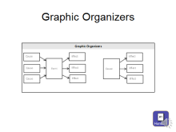
The third strategy is to create a graphic representation of the key ideas in the passage that will help them identify, summarize, organize and recall what they read.

Feel free to pause the session at this point and take a few minutes to familiarize yourself with the template information for the other text structure types. You may wish to use this handout with some of the upcoming activities in the module.

Slide 17

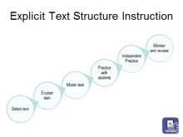
Research clearly supports direct, explicit instruction in how to use text structure to improve comprehension. The same steps elementary teachers use to introduce text structure also apply to middle and high school teachers who are reviewing text structure and helping students apply that knowledge to increasingly complex grade-level text.

First, find well-constructed examples of the text structures you want to review. These examples should contain familiar content or concepts so that students can concentrate on the task of reviewing what they know about text structure without struggling with content.

Then, explain the task to students and why what they are doing is important. You might say something like this: We are going to spend some time this week reviewing the different informational text structures that are used in what we read in this class, because using what you know about text structure is one strategy to help you improve your reading comprehension.

Teacher modeling would include not only how to recognize a particular structure , but also what questions to ask and answer and visual ways to display the information that helps them locate, organize, understand, and recall what they read.

Then, as with all direct, explicit instruction, provide opportunities for guided practice with teacher feedback, followed by independent practice and application of the strategy.

And finally, teach and remind students that using text structure as a way to improve their reading comprehension is not a one-time event. Build recurring reminders and distributed practice opportunities into lesson plans until use of text structure knowledge becomes a strategy students apply automatically when they approach new informational text.

For a more detailed description of how to provide text structure instruction, please see Handout #2, developed and shared with us by Dr. Ruth Gumm from her work at the Florida Department of Education.

Slide 18

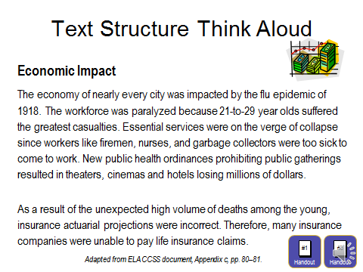
So far we’ve learned about the research on text structure knowledge, how text structure is addressed in the Common Core State Standards, the three key strategies students should use to help them become better readers of informational text, and the steps involved in direct, explicit instruction and subsequent review. Now, let’s see what a lesson might look like if a middle or high school teacher were reviewing previously learned text structure information with students and how to apply that knowledge to better comprehend a grade-level passage.

Here is an example of a Think Aloud a teacher might use to model that process. The two handouts you will need to participate in this activity are Handouts #1 and #3. Handout #1 will help you identify the text structure of the passage through the use of signal words. Handout #3 contains a copy of the passage in this slide, which you can use to underline the signal words as you do the first read and select the correct responses to the key questions I will
raise during the Think Aloud.

Normally, I would start by having students in a classroom read this passage chorally and search for signal words. However, since that isn’t possible in this case, please pause the module now, read the passage silently (or chorally if you are with colleagues), and underline signal words as you find them. Hit the play button when you are finished reading the passage, underlining the signal words, and identifying the text structure of this passage.

Slide 19

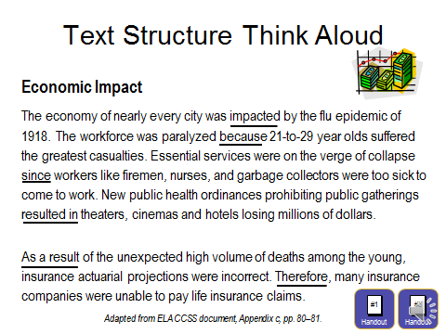
After the choral read, I might say something like this:

Wow. These two paragraphs have a lot of information in them and some of it was kind of hard to understand. One thing that might help me understand what these paragraphs are about is to figure out what kind of text structure the author used. Let’s see if there are any signal words in here that match the templates we have. OK, I see impacted, because, since, resulted in, as a result of and therefore. That would suggest this is cause-effect. So, it was written to explain something that happened and why. Now, if I look back at the sub-heading and then the topic sentence, I think what I need to learn is how the flu epidemic of 1918 effected the economy. I can do that by finding all the things that happened (the effects) and then reading to see why each thing happened. Then, if I connect all the effects (what happened) with the causes (why they happened) by creating a chart or diagram, I’ll be able to understand and remember the ways the flu epidemic impacted the economy in cities around the country.

Even though this structure is referred to as cause and effect, having students look for the effect first and then the cause seems to produce better understanding. I’ve always maintained that this structure would be much easier for students to understand if we had just called it “effect and cause” in the first place!

Slide 20

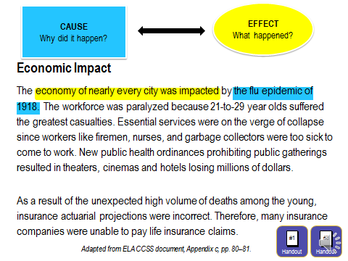
As you can see from Page 5 in Handout #1, there are a number of comprehension question frames that students can select from to ask and answer as they read cause and effect passages, depending on the author’s focus and the complexity or depth of the topic. As a simple scaffolding activity, I encourage students to jot down these very basic definition questions to refer to as they read. The effect generally answers the question “What happened?” And the cause generally answers the question “Why did it happen?”

After modeling the use of signal words and other clues to identify this as a cause and effect passage, I would show students how using my knowledge about text structure helped me understand the passage. As I ask and answer questions about the text, feel free to participate by marking your answers on Page 1 of Handout #3. Or if you want time to identify the causes and effects before I walk you through the Think Aloud with the answers, you can pause the module here and restart it when you have marked your responses.

My Think Aloud for the asking and answering questions strategy might sound something like this. Also note that I include some embedded vocabulary instruction as I model my thinking:

What was the main thing that happened and why? The cities were impacted economically because of the flu epidemic of 1918.

Slide 21

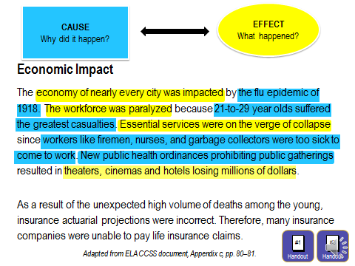
What was the first thing that happened to impact the economy? The workforce was paralyzed.

What made that happen? The younger age group of workers suffered the greatest casualties. I assume that means more of them got the flu, and more of them died.

What was the next thing that happened? Essential services were about to collapse.

What was causing that? The firemen, nurses, garbage collectors who performed those essential services were too sick to come to work.

What else happened to weaken the cities’ economies? Theaters, cinemas and hotels were losing money. Hmm. That’s a confusing sentence. Aren’t theaters and cinemas the same thing? Oh, I remember now from other things we read. Back then, what we call theaters showing movies were called cinemas, and theaters were places where plays and other live performances took place.

Ok, so what was causing these places to lose money? New public health ordinances were not allowing public gatherings.

Slide 22

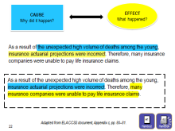
This last paragraph is tricky. But I think an important thing that happened (the effect) was that insurance actuarial projections were incorrect. What caused that was all of the unexpected deaths among the young people.

What was the last thing that happened in this paragraph? The insurance companies couldn’t pay the life insurance claims they owed people.

And why did that happen? Because the actuarial projections were wrong.

Hmm. So, in this paragraph, actuarial projections being wrong was both a cause and an effect. It was the effect that was caused by the unexpectedly high number of deaths among young people, and it was the cause that explained why the insurance companies weren’t able to pay their claims.

Slide 23

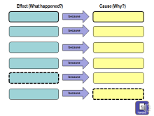
Once students identify the major events and their causes by asking and answering questions during reading, they should use the last of the three informational text structure strategies, which is to complete a cause and effect graphic organizer during or after reading. A blank cause and effect graphic organizer for this passage is on page 2 of Handout #3. Note that in this graphic organizer, the event that was both a cause of one thing and an effect of another is represented by the boxes made from dotted lines. In passages where causes and effects overlap, that is each effect then causes the next event to happen, a cause and effect chain graphic organizer would be the best option.

You may wish to pause this module now and complete the graphic organizer using the answers you found to questions raised during the previous activity. When you are done, resume playing the module.

Slide 24

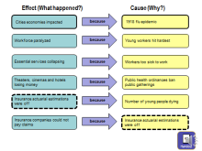
Your graphic organizer might look something like this. Once students have completed the graphic organizer, either on their own, in pairs, or as part of a small group, it is important to make sure they understand how that activity helped their comprehension. You might want to ask discussion questions like these:

Now do you understand this article better than you did when we read it together that first time? How did doing this help?

Responses might include some version of these important points.
- The graphic organizer gave them a visual summary of critical information (or a set of notes to study from).
- It was easier to remember what happened when they put the information in order.
- Connecting the events to what caused them made it easier to understand what they read about.

Slide 25

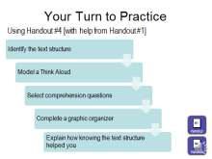
Now that you have seen what direct instruction in teaching about or reviewing one text structure (cause and effect) might look like, let’s take some time for you to try one on your own. Please locate Handout #4 entitled Your Turn to Practice. Select one of the sample passages numbered 1 through 4 and complete the steps on this slide for that passage. You will also want to refer to Handout #1 where the one-page templates for each text structure are located. If you are watching with colleagues, you could work in pairs or small groups and present your lessons to each other for feedback.

First, select the text structure type your passage represents. Then, model a Think Aloud for students that would help them identify the text structure. Be sure to model how you think about the purpose of the passage and how you look for signal words.

Next, select the best comprehension questions for students to ask and answer about that passage. Again, model a Think Aloud of asking and answering those questions that you would use with students just like I did with the flu epidemic passage. Then, put the important information into a graphic organizer; you can use one from Handout #1 or create your own.

Finally, explain how knowing the text structure helped you find, organize, understand, and remember the information in the passage. In other words, how did using text structure knowledge help you comprehend what you read?

If you choose not to pause now, this practice activity can be completed later using the examples in the handout or passages from your own curriculum materials.

Slide 26

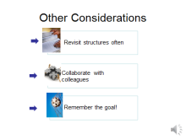
One hallmark of a good reader is text structure awareness and use. However, students need to be reminded frequently to identify text structure as a regular part of each reading experience, and to use that knowledge to organize, locate, recall, and understand the information in the text. Discussion of text structure knowledge and use as a strategy for improving comprehension should be thoughtfully and intentionally built into lesson plans in all content areas. As with most comprehension skills, additional instruction and guided practice may be needed as the complexity of text increases through the grade levels.

Teachers face two common roadblocks in teaching text structure: finding time to identify informational texts they can use for reviewing and practicing the various text structures, and planning lessons that help students apply text structure knowledge to their content area reading. Teachers can collaborate to compile examples, develop lessons based on current curricula, and even practice text structure instruction. A school-wide or district-wide collaborative approach to providing text structure instruction can improve students’ comprehension of grade-level informational text within and across disciplines.

Finally, a caveat as you teach about informational text structure. Always keep in mind that having students correctly identify the basic text structure of a passage is not the goal of text structure instruction. The goal is for students to internalize knowledge about text structure and use that knowledge to improve their own reading and writing.

Slide 27
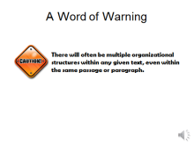
Even though research supports teaching and practicing text structures one at a time and using text that offers clear examples of the specific text structure you are addressing, it is important to remind students early in the process that most texts don’t have just one, easy to identify, text structure.

In fact, at the middle and high school level, most informational text read includes multiple organizational structures throughout, sometimes within the same passage or even within a single paragraph in a passage.

For example, in a science article about advances in alternative energy sources, there might be one section explaining each energy source using description as the organizational structure, while another section or paragraph might discuss the advantages and disadvantages of each using compare and contrast. A third section or paragraph written in problem-solution structure might outline the difficulties in making these energy sources cost-effective and ways scientists are finding to reduce production costs.

Let’s do an activity to show you how you might teach students to do a quick scan of a history lesson that would set the stage for using text structure as a comprehension aid.

Slide 28

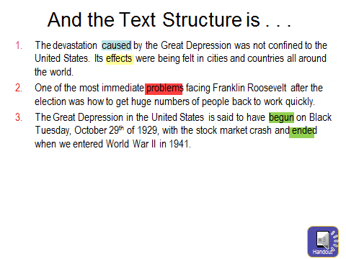
Here are some topic sentences that would be typical of a chapter in an American history text about the Great Depression. Each topic sentence contains some clues as to how the section of text following it might be structured.

Handout #5 contains the topic sentences for this activity and a space for identifying what text structure each topic sentence probably represents. You may wish to pause the module now, locate the worksheet, fill in your responses, and restart the session when you are finished. Otherwise you may read from the slide as I discuss the responses and retrieve the worksheet at a later time.

The first set of sentences in example #1, which contain both the words cause and effect, would seem to indicate that what follows would probably be written in a cause and effect structure and detail how what was happening with the U.S. economy impacted the rest of the world.

Topic sentence #2 seems to suggest a passage written using a problem-solution structure, explaining how President Roosevelt went about solving the problem of getting lots of people back to work quickly.

With references to beginning and ending dates in topic sentence #3, what follows would most likely be written using a sequencing text structure, explaining in sequential order the major events that characterized the Great Depression.

Slide 29

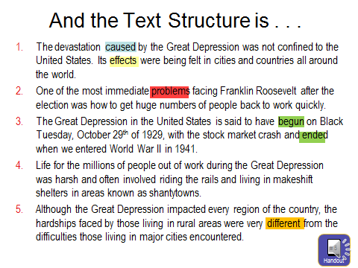
Topic sentence #4 seems to set the stage for explaining what life was like for the majority of Americans impacted by the Great Depression and is probably written as description.

The final topic sentence on our list includes the word different which is a common signal word for the compare-contrast text structure. It also includes information about what will be compared: the hardships faced by people living in rural areas and those faced by their urban counterparts.

A variation on this activity would be to give students a broad topic they might read about in your classroom and ask them to write beginning sentences for paragraphs that would follow each of the five common text structures.

Once students have identified the text structure of a section of text, they can apply the appropriate questioning and graphic organizer strategies that will help them understand the text.

Putting pre-reading activities like this one into content area lesson plans helps students learn to take advantage of what they know about text structure or reminds them to include text structure information as a support for comprehension. And remember what the research findings were about text structure instruction. The time spent on these activities does not reduce the amount of content students can learn. In fact, explicit instruction in text structure facilitates comprehension.

Slide 30

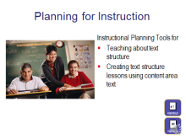
Handout #6 can be used after this module to help you plan two types of informational text structure lessons. The first planning tool on page 1 can be used to design review lessons in each of the common text structures based on what you have learned in this module. Lessons include the three research-based strategies, other key considerations like selecting the appropriate texts to use, and follow-up activities for student practice.

The second tool, on page 2 of that same handout, will help you plan lessons around reading content-area materials using informational text structure knowledge as a strategy for improving comprehension. Remember, students will need repeated exposure to this practice of using text structure to improve their comprehension before they understand it completely and automatically apply on their own.

Handout #1, which includes the templates for each of the common text structures, should also be helpful as you plan for both kinds of instruction.

Slide 31

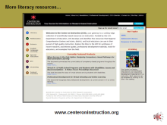
This concludes today’s module on Using Knowledge of Text Structure to Improve Comprehension in Grades 6-12. There is a second module in this Informational Text Structure series that provides professional development for kindergarten through 5th grade teachers. That module provides information about research-based initial instruction in recognizing and using the various text structures, a foundation that prepares elementary students to use text structure knowledge as a strategy for comprehending increasingly complex content area texts in middle and high school. That module is also available on the COI website. Look for Informational Text Structure: Using Knowledge of Text Structure to Improve Comprehension in Grades K-5.

A reminder for those of you viewing both modules, much of the same information is included in both because it applies to all grade levels. The differentiation between the two modules occurs in the activities and examples that make them applicable to the grade bands addressed in the module.

Be sure to visit the Center on Instruction (COI) website to find additional resources that can support all schools with their improvement efforts.

COI offers materials to support:
  - leadership,
  - improving literacy instruction,
  - professional development, and
  - implementing college- and career-ready standards, including the Common Core State Standards.

Slide 32

Thank you for your time and attention! It has been a pleasure to share information about text structure instruction with you. Remember to review the Module 2 Handouts, Resources, and References document that provides references and resources for additional sources of information to assist you in learning about and planning for teaching students to use text structure knowledge to improve their comprehension.

