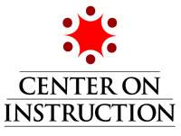

MODULE 1: INFORMATIONAL TEXT STRUCTURE:
USING KNOWLEDGE OF TEXT STRUCTURE TO IMPROVE COMPREHENSION IN GRADES K-5
TRANSCRIPT

SLIDE 1

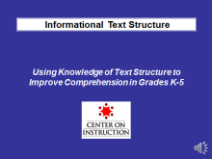
Hello everyone and welcome! Thank you for joining the Center on Instruction’s module on Informational Text Structure: Using Knowledge of Text Structure to Improve Comprehension in Grades K-5.

This is one of two professional development modules on informational text structure instruction. The other module focuses on text structure instruction for adolescents in grades 6 through 12. Both modules are designed to provide key principles and practices that support classroom literacy instruction. Each module provides resources useful to schools working to improve literacy instruction, as well as technical assistance providers and others interested in school improvement.

In this module, I will refer to several handouts that can be downloaded with this module. When I refer to a handout, feel free to pause this presentation to locate it. You may also wish to refer to the document “Module 1 Handouts, Resources, and References” for a complete list of all handouts provided as well as other resources that can support your understanding of this topic and references we used to develop this module.

My name is Vicki LaRock. I am from RMC Research Corporation and serve as a reading content specialist with the Center on Instruction’s Literacy Team. I will be presenting this module on Using Knowledge of Text Structure to Improve Comprehension in Grades K-5.

SLIDE 2

It is important to start with the participant goals for this module. The objectives include:

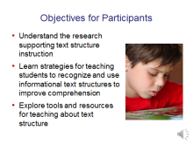
- understanding the research that supports instruction in informational text structures,
- learning about key instructional strategies that help students recognize various text structures and use that knowledge to improve their comprehension, and
- exploring tools and resources to help in planning and delivering effective text structure instruction.

It is also important to acknowledge that teaching about text structure applies to both narrative and informational text and the research supports direct, explicit instruction in both.

These modules will focus only on informational text for two reasons:

- Children in the early grades generally have had much more exposure to narrative text than informational text, and teachers are more familiar with teaching students about the elements of story structure.
- The increased emphasis on reading informational text found in the Common Core State Standards and other college- and career-ready standards will require teachers to provide students with the tools and strategies they need for comprehending increasingly complex informational texts to meet these new standards.

Slide 3

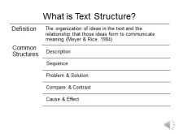
Since participants viewing this module may have varying degrees of familiarity with text structure, let’s start by defining it. There are a surprising number of different definitions of text structure in the literature. The definition on this slide seems to capture the essence of what text structure is and its connection to comprehension.

Text structure refers to the organization of ideas in a text and the relationship that those ideas form in order to convey meaning.

The five most common informational text structures that students in grades K-5 encounter in their reading are description, sequence or chronology, problem-solution, compare and contrast, and cause and effect.

Slide 4

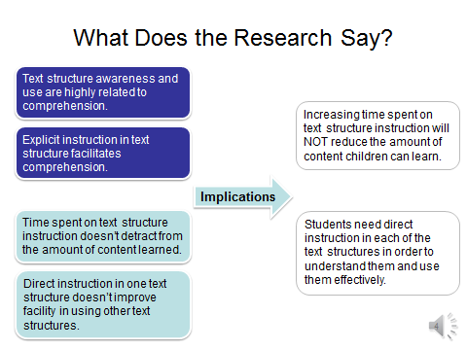
Text structure research studies over the last 25 years consistently show that teaching students about the organization of text, or text structure, has a positive effect on comprehension and that awareness of text structure is one hallmark of a good reader.

The convergence of evidence from individual studies and at least one meta-analysis suggests that:

- Text structure awareness and use are highly related to comprehension, and
- Direct, explicit instruction in text structure facilitates comprehension.

Multiple studies have also confirmed two other findings that are important to keep in mind as we think about the role of text structure instruction in improving comprehension:

- Spending time on text structure instruction does not negatively impact the amount of content learned, and
- Direct instruction in one type of text structure does not improve a child’s ability to use other text structure types in comprehending text.

Two classroom implications for these findings are that:

- Increasing the time teachers spend on text structure instruction will not reduce the amount of content children can learn, and
- Students need direct instruction in each of the text structures in order to understand them and use them effectively to improve comprehension.

Slide 5

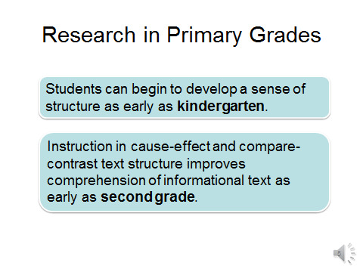
Much of the initial research on informational text structure instruction was conducted with older students. Text structure research in the early grades tended to focus on narrative text. However, many recent studies have examined the impact of informational text structure instruction in the primary grades and concluded that students can begin to develop a sense of structure as early as kindergarten. Also, instruction in cause-effect and compare-contrast text structures improves comprehension of informational texts in students as early as second grade.

Slide 6

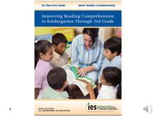
A panel of researchers convened by the Institute of Education Sciences (IES) developed this Practice Guide, Improving Reading Comprehension in Kindergarten Through 3rd Grade, that identifies six recommended practices supported by research. Recommendation #2 is to “Teach students to identify and use the text’s organizational structure to comprehend, learn, and remember content” by explaining “how to identify and connect the parts of narrative text” and providing “instruction in common structures of informational text.”

The authors reinforce the importance of starting text structure awareness instruction early on. They point out that after a read-aloud, even kindergarteners can arrange a scrambled set of pictures into proper sequence of steps or events. They can also sort pictures into same and different groups after a compare-contrast read-loud or match up cause and effect pictures after a read-aloud written in that organizational structure.

Slide 7

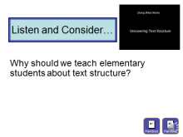
To learn more about the rationale for teaching informational text structure at the elementary level, let’s listen to excerpts from a Doing What Works video presentation by Dr. Joanna Williams. Much of Dr. Williams’ recent research involves studying the effects of direct text structure instruction on comprehension of social studies and science texts in the primary grades and aligns with the findings from the IES Practice Guide.

The section we will watch focuses on informational text. However, the video contains information about narrative text structure as well. Handout #1 contains a written transcript of the complete video.

Consider this critical question as you observe the video segment: Why should we teach elementary students about text structure? Record your response to this question and any other notes you wish to capture on Handout #2, The Doing What Works Media Viewing Guide.

When you finish watching the video, pause and take a few minutes to discuss with colleagues or reflect individually on what you’ve learned.

Slide 8
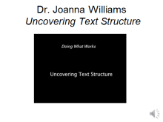
Full Transcript of Video

I’m Joanna Williams, professor of psychology and education at Teachers College, Columbia University.
It’s very important to teach elementary school children, K–3, about text structure, because it’s something tangible in the area of comprehension actually that we can teach. There’s something there to show children, and they can learn it. Text structure helps children in their reading because it organizes the content of what they are reading. They’re reading facts, they’re reading pieces of information and so forth, and they need some way of structuring or organizing that information. Good text is well structured, and a child who learns about structure will have the cues available and the means to pull out those important pieces of text.
There are several basic features of narrative text. First of all, narrative texts are stories, and they talk about people and events. And so one of the most important features about a narrative or a story is: Who is it about? (The main character.) And then what did the main character do? (The central event of the story.) How did the main character feel about it? And then there’s usually some sort of conflict, and a resolution of that conflict, and then a conclusion to the story.
Now, these are little pieces of the story, and they usually appear in the same sequence in a story. And what we do is teach the children those features so that they will have an understanding, on an abstract level really, of what a story consists of, and then they can look for those features when they hear a new story.
Understanding informational texts is a little different from understanding narrative texts. Children aren’t usually faced with informational or expository text as soon as they are with narrative, and it’s a little different because expository text is usually more difficult to understand. And the reason for that is that it’s usually about abstract issues, not simply main characters and their events and so forth. So that, plus the fact that usually the language that expository text is written in is a little different, is a little more formal, it makes that kind of text, informational or expository, more of a challenge for children.
The other issue is that while there’s only one narrative structure, there are several expository structures. There is compare/contrast; there is description, sequence, cause/effect, problem/solution. And there is a different structure for each one of those, and children really have to be introduced to each one separately.

Slide 9

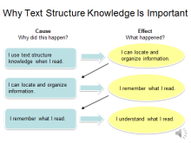
I’ve taken the liberty of combining what Dr. Williams said in the video with findings from other researchers into a cause and effect chain explaining why learning about text structure and applying that knowledge is so important to comprehension.

This graphic organizer could be used as a tool for explaining to elementary students why learning about text structure is important and how it can help them be better readers. You might explain it to students this way:

Because I used my knowledge about text structure when I read this book, that helped me locate and organize the information. Because I was able to find and organize that information, I could remember it better. And because I was able to remember more of what I read, it was easier to understand it.

Applying text structure knowledge, not just identifying the text structure, is critical. Teaching students about text structure is a means to an end—comprehension—not an end itself.

Comprehension of grade level informational text is a keystone of rigorous college- and career-ready literacy standards such as those exemplified in the Common Core State Standards.

Slide 10

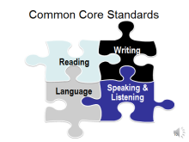
The Common Core State Standards, which have been adopted by most states, are divided into four inter-related strands: Reading, Writing, Speaking and Listening, and Language.

Slide 11

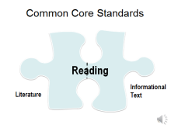
Although there is a single set of College and Career Readiness Anchor Standards for Reading, there are two separate subsets of grade-specific reading standards: one for Literature and one for Informational Text. Comparing the two makes it clear that the knowledge and skills required to be successful readers of literature are different from those required of successful readers of informational text.

Although we won’t take time to do that during this module, engaging teachers in a comparison of the two subsets of reading standards would be valuable professional development to help teachers understand the differences.

Slide 12

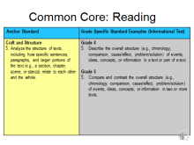
The Common Core State Standard that most explicitly addresses text structure knowledge is Reading Anchor Standard 5 on the left of this chart, and the grade specific Informational Text standards listed on the right. However, students are expected to meet a number of other reading standards that also require knowledge of informational text structures, such as describing the connections between sections of a text and explaining the relationships between events, ideas, or steps in a procedure.

References to text structure knowledge are found throughout the other strands as well. The writing standards require students to convey complex ideas and information clearly through the organization of the content and produce writing in which the organization is appropriate to task and purpose. The language standards ask students to use context, such as cause/effect relationships and comparisons, as one strategy for determining the meaning of unknown words or phrases.

Slide 13

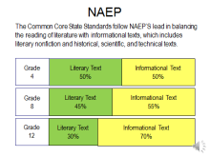
The framework for the National Assessment of Educational Progress (NAEP) reading test uses this distribution of literary to informational text. It begins with a 50-50 balance between the two at the elementary level and increases the emphasis on informational text at the higher grade levels. The Common Core State Standards are aligned with this framework and follow NAEP’s lead in calling for 50% of the texts students read to be informational in the elementary grades, beginning in kindergarten.

This is sometimes misunderstood as 50% fiction and 50% non-fiction, or expository text. It is important to keep in mind that Informational Text is an umbrella term that includes literary nonfiction like biographies and autobiographies; books about history, social studies, science, the arts, and technical subjects; information displayed in graphs, charts and maps; and digital sources.

This increased focus on reading informational text will require elementary teachers to provide explicit, direct instruction in how to read informational text. Teaching students about text structure and how to use that knowledge to organize, remember, and understand information will be key in helping students meet the literacy demands of college- and career-level reading.

Let’s take a look at some common text structures.

Slide 14

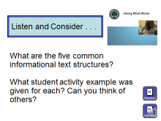
This multimedia overview from the Doing What Works website provides examples of the most common text structures and student activities that could be used when teaching about them.
The section we will watch deals with informational text. However, the multimedia overview contains information about narrative text structure as well. Handout #3 contains a written transcript of the complete video.

Consider these questions as you observe the narrated slides: What are the five common informational text structures? and What student activity example was given for each? Can you think of others? Record your responses to these questions and any other notes you wish to capture on Handout #2, the Media Viewing Guide.

When you finish watching the slide show, pause and take a few minutes to discuss with colleagues or reflect individually on what you’ve learned.
Slide 15

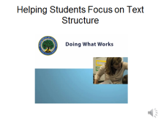
Full Transcript of Video

Slide 1: Welcome

Welcome to the overview on Helping Students Focus on Text Structure.

Slide 2: Text structures

Helping students understand how different types of texts are structured can greatly improve their reading comprehension. As students gain a firm grasp of narrative and informational text structures, they can apply that knowledge when they approach more advanced materials. This process can begin as early as
kindergarten.
Slide 3: Narrative texts

Let’s look first at introducing children to narrative texts, which can be described as texts that tell stories about characters. This covers a wide range, from folk tales to biographies.

Students can learn how to identify and understand the five main elements of structure in narrative text:

- Characters,
- Setting,
- Problem,
- Plot, and
- Resolution
Slide 4: Teaching techniques

Teachers can introduce students to tools and techniques to help them remember the story elements. For example, students can count them off, associating one element with each finger on their hand.

Story maps or graphic organizers can also be used to teach the parts of a story, such as:

- A chart that helps students match structure to content,
- A sequencing activity for younger students in which they rearrange a scrambled list of pictures to accurately represent the sequence, or
- A diagram of the plot that connects major action points within the story.

When introducing these tools, teachers should explain how each tool or strategy can help students understand what they are reading. This way, students are more likely to think about the story elements as they read, and not just when the tools are used in class discussion.

Slide 5: Instruction across grades

Instruction on text structure will look different across grade levels. For kindergarten students, teachers can identify narrative elements by asking questions while reading, such as:

- Where does this story take place?
- Who was the main character?
- What happened?
- How did the story end?

As students get comfortable with the five elements, teachers can introduce stories with multiple examples of each element and have students identify each of them. For example, with Little Red Riding Hood, the setting is both the woods and grandmother’s house.

With older students, teachers should gradually introduce new structural elements—such as themes, morals, subplots, and multiple conflicts—while reinforcing those that have already been taught.

Slide 6: Informational texts

Teachers should also introduce students to the structural elements of informational or expository text. For beginning learners, it’s important to use texts that provide clear, easy-to-recognize examples of the structure being taught.
Slide 7: Examples of structures and exercises

Examples of informational text structures include compare and contrast, description, sequence, problem and solution, and cause and effect.

- A compare-and-contrast text might present types of animals or modes of transportation. Students can work together to create a table or Venn diagram of the similarities and differences between the objects in the text.
- With a description text, students might use the details of what is being described to draw an illustration or create a three-dimensional display.
- A text that outlines a sequence of events can be made visible by assigning each event in the text to a student, and having the class line the students up in the correct order.
- When working with a problem-and-solution text, students may be able to act out key parts of the passage.
- Cause-and-effect texts can be explored by matching up pictures that represent causes and effects in a game-like activity.
Slide 8: Clue words

Students can also be helped to recognize clue words in a passage so that they can identify the text structure. Words such as alike, unlike, both, but, and however can signal a compare-and-contrast text, while before, after, next, and then can indicate a sequence-of-events text.

It is important, however, that students are not taught to rely solely on clue words to identify text structure.

Slide 9: Variety of text examples

As students grow more adept at working with informational texts, examples can move from short passages to paragraphs to larger texts that may contain multiple structures. For example, a magazine article may include a description of an event, some information about its position in a sequence of other events, and an explanation of cause and effect.

Teachers should provide a variety of examples when showing students how texts can contain more than one structure.
Slide 10: Encouraging constant awareness

Students should be encouraged to pay attention to text structure in all of their reading experiences, and may need to be reminded to do so before reading periods.

Slide 11: Tools for teachers

Teachers can use common lesson-planning time to collaborate on identifying texts with clear examples of narrative elements and expository structures. There are also book lists that identify ideal texts for this kind of instruction.

Slide 12: Integration with other recommendations

Students can focus on structure as they discuss text or practice comprehension strategies.

Understanding the underlying features of texts will support them as readers and writers as well as in their conversations about text.

This recommendation pairs well with other K–3 reading comprehension recommendations available on this Website.
Slide 13: Learn more

To learn more about Helping Students Focus on Text Structure, please explore the additional resources on the Doing What Works website.

Slide 16

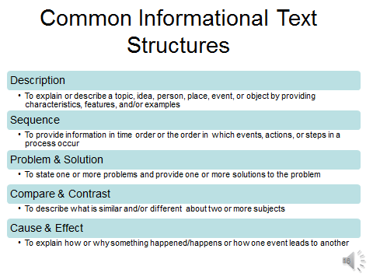
The five most common informational text structures explained in the video were description, sequence or chronology, problem and solution, compare and contrast, and cause and effect. Let’s pause for a moment and read the brief description of each of these structures we will be working with and talking about as we go through this module.

Slide 17

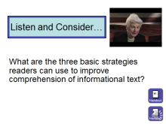
We heard Dr. Williams talk about the rationale for teaching informational text structure at the elementary level. Now let’s listen to another excerpt from the video to learn about the three research-based strategies we need to teach students to apply so they can use text structure to help them comprehend what they read.

Again, this section deals with informational text. However, the video contains information about strategies to apply to narrative text structure as well. Handout #1 contains a written transcript of the complete video.

Consider this key question as you observe the video segment: What are the three basic strategies readers can use to improve comprehension of informational text? On Handout #2, record your responses to this question and any other notes you wish to capture.

When you finish watching the video, pause and take a few minutes to discuss with colleagues or reflect individually on what you’ve learned.
Slide 18

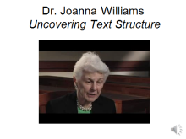
Full Transcript of Video

Now, there are different kinds of specific tools you can use. And what I’ve been doing in my research is trying to develop such tools and really build them into instructional programs.
My narrative work consists of what we call the Themes Scheme, and the Themes Scheme is a set of questions, which highlight the important information in a text. And children learn to essentially recite and use the questions as strategy questions. The first questions are about the plot level: Who was the main character? What was the main event? And that sort of thing. And then they focus in on the event and the resolution because those are the two most important parts of a story, and then they evaluate them: Was it good or was it bad?
When I work with expository text structure, it’s a little different; it’s a little more complicated, because, first of all, we have to choose which kind of expository structure we are teaching. And we have done several, including compare/contrast, and we have developed an instructional program where we teach three basic strategies.
There are clue words, and in compare/contrast there are similar, dissimilar, like, and those kinds of things. So we can use those clue words, and we teach children to find those in paragraphs, and then they know it’s a compare/contrast paragraph. And then they say to themselves, “Well, how can I find the most important information in a compare/contrast paragraph?”
And our second strategy is to teach them the generic questions:

• What is this paragraph about? What two things is this about?
• How are the two things different?
• How are the two things the same?
And they answer those questions.
The third strategy is the use of a graphic organizer, because this just helps them identify and keep in mind the answers to those generic questions.
What we’ve found from our studies is that children really do learn from having this explicit teaching. We have found that they do better on comprehension tests that we develop, that they can read other material that they haven’t seen in instruction and in the same area—social studies. And what is also very good, I think, is that they have learned just as much about the content, the social studies content, as they would have if they hadn’t had any of the embedded reading comprehension training.
It’s very important for children to understand that text has meaning, and if they just sound out words, they are not really, really reading. So they have to understand that they need to get meaning, and text structure is a way to get into that for them.

Slide 19

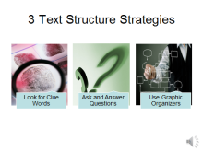
To summarize, the three research-based strategies students should be taught in order to recognize text structure and use that information to improve comprehension are:
- looking for clue (or signal) words in the text,
- learning a few generic questions to ask and answer for each structure, and
- using graphic organizers to help them find, organize, and remember the content.

The majority of our time will be spent learning about and seeing what these strategies look like in the classroom, practicing how to teach some of them, and becoming familiar with some resources designed to support informational text structure instruction.

First, let’s orient ourselves to these three strategies by looking at some examples of what they might look like for each text structure.

Slide 20

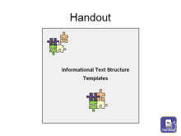
Handout #4, Informational Text Structure Templates, provides a one-page information sheet on each of the five common structures found in informational text. The content includes the purpose, signal words and phrases often associated with that text structure, examples of key questions to ask and answer while reading, and sample graphic organizers that lend themselves to that text structure.

The templates were designed to span multiple grade levels. And their purpose is two-fold. Teachers can use them as an aid when planning text structure lessons. And teachers can adapt them for student or classroom use by selecting signal words, comprehension question frames, and graphic organizer examples appropriate for their grade level and content.

Please pause and take a few minutes to familiarize yourself with the templates. You may wish to use them with some of the upcoming activities in the module.

Slide 21

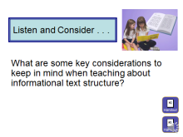
In addition to the examples we saw earlier about text structures and student activities that could be used when teaching them, this overview also introduces other considerations to keep in mind when planning for and providing text structure instruction.

Again, the section we will watch deals with informational text. However, some of the instructional considerations apply to teaching about narrative text structure as well. Handout #3 contains a written transcript of the complete video.

Consider this question as you observe the narrated slides: What are some key considerations to keep in mind when teaching about informational text structure? Record your responses to this question and any other notes you wish to capture on Handout #2.

When you finish watching the slide show, pause and take a few minutes to discuss with colleagues or reflect individually on what you’ve learned.

Slide 22

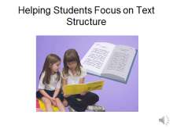
Full Transcript of Video

Slide 1: Welcome

Welcome to the overview on Helping Students Focus on Text Structure.

Slide 2: Text structures

Helping students understand how different types of texts are structured can greatly improve their reading
comprehension. As students gain a firm grasp of narrative and informational text structures, they can apply that knowledge when they approach more advanced materials. This process can begin as early as kindergarten.

Slide 3: Narrative texts

Let’s look first at introducing children to narrative texts, which can be described as texts that tell stories
about characters. This covers a wide range, from folk tales to biographies.

Students can learn how to identify and understand the five main elements of structure in narrative text:
- Characters,
- Setting,
- Problem,
- Plot, and
- Resolution.

Slide 4: Teaching techniques

Teachers can introduce students to tools and techniques to help them remember the story elements. For example, students can count them off, associating one element with each finger on their hand.

Story maps or graphic organizers can also be used to teach the parts of a story, such as:

- A chart that helps students match structure to content,
- A sequencing activity for younger students in which they rearrange a scrambled list of pictures to accurately represent the sequence, or
- A diagram of the plot that connects major action points within the story.

When introducing these tools, teachers should explain how each tool or strategy can help students understand what they are reading. This way, students are more likely to think about the story elements as they read, and not just when the tools are used in class discussion.

Slide 5: Instruction across grades

Instruction on text structure will look different across grade levels. For kindergarten students, teachers can
identify narrative elements by asking questions while reading, such as:

- Where does this story take place?
- Who was the main character?
- What happened?
- How did the story end?

As students get comfortable with the five elements, teachers can introduce stories with multiple examples of each element and have students identify each of them. For example, with Little Red Riding Hood, the setting is both the woods and grandmother’s house.

With older students, teachers should gradually introduce new structural elements—such as themes, morals,
subplots, and multiple conflicts—while reinforcing those that have already been taught.

Slide 6: Informational texts

Teachers should also introduce students to the structural elements of informational or expository text.
For beginning learners, it’s important to use texts that provide clear, easy-to-recognize examples of the
structure being taught.

Slide 7: Examples of structures and exercises

Examples of informational text structures include compare and contrast, description, sequence, problem
and solution, and cause and effect.

- A compare-and-contrast text might present types of animals or modes of transportation. Students can work together to create a table or Venn diagram of the similarities and differences between the objects in the text.
- With a description text, students might use the details of what is being described to draw an illustration or create a three-dimensional display.
- A text that outlines a sequence of events can be made visible by assigning each event in the text to a student, and having the class line the students up in the correct order.
- When working with a problem-and-solution text, students may be able to act out key parts of the passage.
- Cause-and-effect texts can be explored by matching up pictures that represent causes and effects in a
game-like activity.
Slide 8: Clue words

Students can also be helped to recognize clue words in a passage so that they can identify the text structure. Words such as alike, unlike, both, but, and however can signal a compare-and-contrast text, while before, after, next, and then can indicate a sequence-of-events text.

It is important, however, that students are not taught to rely solely on clue words to identify text structure.

Slide 9: Variety of text examples

As students grow more adept at working with informational texts, examples can move from short passages to paragraphs to larger texts that may contain multiple structures. For example, a magazine article may include a description of an event, some information about its position in a sequence of other events, and an explanation of cause and effect.

Teachers should provide a variety of examples when showing students how texts can contain more than one
structure.
Slide 10: Encouraging constant awareness

Students should be encouraged to pay attention to text structure in all of their reading experiences, and may need to be reminded to do so before reading periods.

Slide 11: Tools for teachers

Teachers can use common lesson-planning time to collaborate on identifying texts with clear examples of
narrative elements and expository structures. There are also book lists that identify ideal texts for this kind of instruction.

Slide 12: Integration with other recommendations

Students can focus on structure as they discuss text or practice comprehension strategies.

Understanding the underlying features of texts will support them as readers and writers as well as in their
conversations about text.

This recommendation pairs well with other K–3 reading comprehension recommendations available on this
website.
Slide 13: Learn more

To learn more about Helping Students Focus on Text Structure, please explore the additional resources on
the Doing What Works website

Slide 23

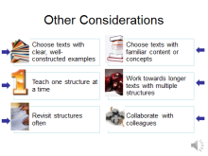
Several key considerations discussed in this overview and/or mentioned previously in the module are important to think about as we plan for instruction. Take a moment to read and think about these best instructional practices before we discuss them.

- In the initial teaching of text structure, it is important to find texts that provide clear, well-constructed examples of the text structure you want to teach and that use some of the signal words associated with that structure.

- The IES Practice Guide also suggests using texts that contain content or concepts that are familiar to students, examples they can identify with when they are first learning a new structure. That way, students can put their cognitive energy towards learning the new task without struggling to learn new content at the same time. For example, initial instruction on Compare/Contrast structure in the primary grades might involve comparing dogs and cats or different modes of transportation—not comparing major religions of the world or the advantages and disadvantages of solar and hydro-electrical power.

- Research has shown that direct instruction in one text structure does not improve student facility in using other text structures to improve comprehension. For example, teaching students to use compare and contrast text structure knowledge when reading will not help them use another structure they have not been previously taught, such as problem and solution. So, it makes sense to teach one text structure at a time, adding new ones as previous ones are mastered.

- Even though we start by teaching one structure at a time and using short passages (or even single sentences at the primary level), the goal is for students to learn to use text structure knowledge to improve comprehension when reading a wide variety of longer texts that contain more than one text structure.

- One hallmark of a good reader is text structure awareness. However, students should be reminded frequently to identify text structure as a regular part of each reading experience and use that knowledge to help them organize, locate, recall, and understand the information in the text.

- Teachers face two common roadblocks in teaching text structure: finding time to identify informational texts they can use to teach the various text structures, and planning lessons that help students understand how to apply text structure knowledge to their reading. Teachers can collaborate to compile examples, develop lessons based on current curricula, and even practice text structure instruction. A school-wide or district-wide collaborative approach to providing text structure instruction can improve students’ comprehension of grade-level informational text in all subjects and throughout the school day.

Slide 24
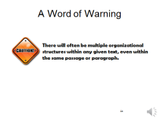
Even though research supports initially teaching about text structures one at a time and using text that offers clear examples of the specific text structure you are teaching, it is important for students to know early in the process that most texts don’t have just one, easy to identify, text structure.

One example for explaining this important concept might be the book Recycle by Gail Gibbons. There are many others you can find within your own libraries. The overall structure of Recycle is problem-solution. The problem is that there is so much garbage that the landfills are overflowing. So the solution is to recycle.

But, the beginning of the book starts with garbage at the curb and shows what happens to it all along the way to the landfill. That part of the book is written using the chronology/sequence structure.

There is also a paragraph that names all the different things that can be recycled, so that is a simple list structure. And, several paragraphs explain how each different type of material gets recycled and what it can be recycled into. Those paragraphs are written using the description structure.

Slide 25

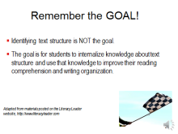
One final word of caution as you begin teaching about informational text structure. Always keep in mind that having students correctly identify the basic text structure of a passage is not the goal of text structure instruction. The goal is having students use what they have learned about informational text structure to improve their own reading and writing.

Slide 26

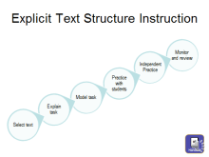
Research clearly supports direct, explicit instruction in how to use text structure to improve comprehension. Thinking through each of the steps of explicit strategy instruction as they apply to text structure instruction should help us get an idea of what that looks like in the classroom.

First find well-constructed examples of the text structure you want to teach. These examples should contain familiar content or concepts, examples that kids can identify with when they are first learning a new structure, so they can concentrate on the task without struggling with content.

Then, explain the task to students by identifying the text structure you are going to teach and telling them why it is important to know that. You might say something like this: We have been learning about different text structures as one way to help us become better readers of informational texts. Today we are going to learn about cause and effect. Cause and effect explains the relationship between two things or events when one event causes another one to happen.

Teacher modeling should include not only how to understand a particular structure and recognize it when they see it, but also what questions to ask and answer and visual ways to display information that would help them locate, organize, understand and recall what they read from passages written in that text structure.

Then, as with all direct, explicit instruction, provide multiple opportunities for guided practice with immediate teacher feedback, followed by independent practice and application of the strategy.

And finally, teaching students to use text structure as one way to improve their reading comprehension is not a one-time event. This should be a recurring practice built into lesson plans for reading informational text and revisited often until it becomes a strategy students apply automatically when they approach a new text.

For a more detailed description of how to provide text structure instruction, please see Handout #5, developed and shared with us by Dr. Ruth Gumm from her work at the Florida Department of Education.

Slide 27

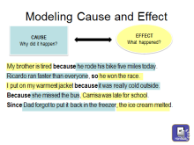
So far we’ve learned about the research on text structure knowledge, the three strategies for teaching about text structure and some of the other considerations for planning and providing direct, explicit instruction. Now let’s take a look at what initial instruction on the cause and effect text structure might look like in an elementary classroom.

This is usually one of the more difficult text structures for students to learn, and it can be the hardest one to teach. Having students look for the effect first and then the cause seems to produce better understanding than working in the other direction. I’ve always maintained this structure would be much easier for students to understand if we had just named it Effect and Cause to begin with instead of Cause and Effect!

Providing a definition of a cause and an effect would be one of the first steps in introducing this structure. The effect is what happened and the cause is why it happened. Explain to students that answering the question “What happened?” identifies the effect and answering the question “Why did it happen?” identifies the cause. Model that strategy with enough examples until everyone demonstrates understanding.

You have a copy of these sentences on page 1 of Handout #6. As I ask the question, you can underline the correct answer, and we’ll check them as we go along.

My brother was tired because he rode his bike five miles today. What happened? My brother was tired. That is the Effect. Why did it happen? Because he rode his bike five miles today. That is the Cause.

Let’s try the next one. Ricardo ran faster than everyone, so he won the race. What happened? Ricardo won the race. That is the Effect. Why did it happen? He ran faster than everyone. That is the Cause.

How about one more together? I put on my warmest jacket because it was really cold outside. What happened? I put on my warmest jacket. That is the Effect. Why did it happen? Because it was really cold outside. That is the Cause.

Now pause and take a minute to do the other two on your own, as if you were modeling this strategy with students.

Here are the correct responses to the last two sentences in case anyone was wondering. At this point you could also bring in the use of signal words. You might ask students to identify the word that appears in three of these sentences (because) and ask if they see a word in the other sentences that means something similar (so and since).

Slide 28

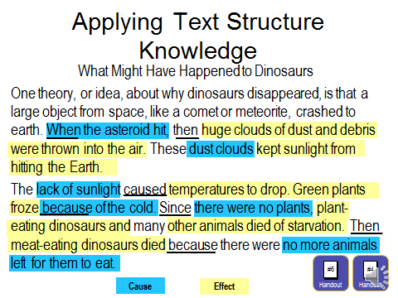
Once students have been taught several text structures and are familiar with the signal words, question frames, and graphic organizers associated with each, the next stage would be applying that knowledge to longer passages of grade level text as a strategy for improving students’ comprehension.

Here is an example of a Think Aloud a teacher might use to model that process. Normally, I would have students in a classroom read this passage chorally. However, since that isn’t possible during this module, please take a moment to read this silently or chorally if you are with colleagues. Pull out Handout #6 and turn to page 3 which contains a copy of this passage or you can read the text on the screen. If you use Handout 6, you can underline the signal words as you read. Also feel free to refer to page 5 on Handout #4, which has the template for Cause and Effect, to see how it might be useful to students as they participate in a lesson like this one.

Pause the module now and hit the play button when you are finished reading and underlining the signal words.

After the choral read, I might say something like this:

Wow. This article was kind of hard to understand. One thing that might help me understand what these paragraphs are about is to figure out what kind of text structure the author used. First I’ll see if there are any signal words in here that match the charts we have. OK, I see when and since. Then and because are in a couple of different sentences. And the word caused is here, too. This is probably cause and effect. So, I think this was written to explain the things that happened to make dinosaurs disappear. Now when I look back at the title I see I must be right. What I need to learn and remember is why the dinosaurs disappeared. I can do that by finding all the things that happened (the effects) and then reading to see why each thing happened. If I connect all the effects (what happened) with the causes (why they happened) by making a chart or diagram, then I will be able to understand why the dinosaurs disappeared, remember what happened, and write about it or tell someone what I know.

Now let’s see if we can do that together.

The next step in the process would be modeling how good readers ask and answer key comprehension questions to help them identify causes and effects in a passage. You can work along with me by circling or underlining the causes and effects on Handout #6 as I ask questions and highlight the answers on the screen. This is what modeling the use of key cause and effect questions as a comprehension strategy might look like and sound like in the classroom.

Well, since this is a cause and effect passage, here are the questions I need to ask myself and answer in order to better understand this text.

What was the first thing that happened? An asteroid hit the Earth. So that seems to be the key event that caused this whole chain of other things to happen, resulting in dinosaurs disappearing from the Earth. I think that is what the word extinct means, but the author didn’t use it here.

What was the effect of the asteroid hitting the Earth? Huge dust clouds formed above the Earth.

What was the next thing that happened? The sunlight couldn’t hit the Earth. What caused that to happen? The dust clouds were blocking the sun.

Without any sun, what happened next? The Earth’s temperature dropped.

Then, what happened and why? The plants all died because of the cold.

Because the plants died, what happened next? The plant-eating dinosaurs and other animals starved. And without those animals to eat, what happened? The meat-eating dinosaurs died, too.

OK. That wasn’t so hard to understand once I thought about how all the different things went together.

Slide 29

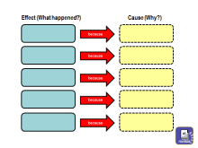
Once students identify the major events and what caused them by asking and answering questions during reading, they should use the last of the three informational text structure strategies, which is to complete a graphic organizer during or after reading. A blank cause and effect graphic organizer for this passage is on page 4 of Handout #6. Because this activity is an example of initial teaching about informational text structure, this is a simple graphic organizer that represents a one-to-one correspondence between each cause and effect. However, this article contains lots of causes and effects where each effect then caused something else to happen, so a cause-effect chain graphic organizer could be used with advanced groups of students or readers who routinely use text structure knowledge to help them understand text.

You may wish to pause this module now and complete the graphic organizer using the answers you found to questions raised during the previous activity. When you are done, resume playing the module.

Slide 30

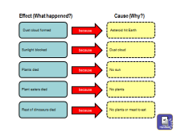
Your graphic organizer might look something like this. Once students have completed the graphic organizer, either on their own, in pairs, or as part of a small group, it is important to make sure they understand how that activity helped their comprehension.
You might want to ask discussion questions like these:

Now do you understand this article better than you did when we read it together that first time? How did doing this help?

Responses might include some version of these important points.
- The graphic organizer gave them a visual summary of critical information (or set of notes).
- It was easier to remember what happened when they put the information in order.
- Connecting the events to what caused them made it easier to understand what they read about.

Slide 31
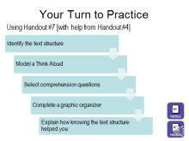
Now that you have seen what direct instruction in teaching one text structure (cause and effect) might look like, let’s take some time for you to try one on your own. Please locate Handout #7 entitled Your Turn to Practice. Select one of the sample passages numbered 1 through 4 and complete the steps on this slide for that passage. You will also want to refer to Handout #4 where the one-page templates for each text structure are located. If you are watching with colleagues, you could work in pairs or small groups and present your lessons to each other for feedback.

First select the text structure type your passage represents. Then model a Think Aloud for students that would help them identify the text structure. Be sure to model how you think about the purpose of the passage and how you look for signal words.

Next, select the best comprehension questions for students to ask and answer about that passage as they read. Again, model a Think Aloud of asking and answering those questions that you would use with students just like I did with the dinosaur passage. Then, put the important information into a graphic organizer from the handout or one you create.

Finally, explain how knowing the text structure helped you find, organize, understand, and remember the information in the passage. In other words, how did using text structure knowledge help you comprehend what you read?

If you choose not to pause now, this practice activity can be completed later using the examples in the handout or passages from your own curriculum materials.

Slide 32

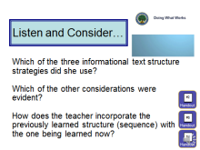
Now that we’ve talked about the research on text structure, learned about the three key strategies and other considerations for teaching text structure and even practiced explicit strategy instruction, let’s take a look at a video from the Doing What Works website that shows a 3rd and 4th grade teacher from Kansas putting it all together as she teaches her students about the compare/contrast text structure.

As you watch the lesson unfold, consider these questions: Which of the three informational text structure strategies did she use? Which of the other considerations were evident? and How does the teacher incorporate the previously learned structure (sequence) with the one being learned now? Use Handout #2 to record your responses to these questions and any other notes you wish to capture.

Handout #8 contains a written transcript of the video. And Handout #9 contains examples of the materials the teacher uses in teaching about informational text structure.

When you finish watching the video, pause and take a few minutes to discuss with colleagues or reflect individually on what you’ve learned.

Slide 33
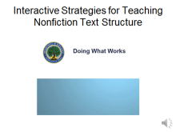
Full Transcript of Video

Slide 1: Welcome
Welcome to Interactive Strategies for Teaching Nonfiction Text Structure.
Slide 2: Introducing Dawn Chappelear
Hi, my name is Dawn Chappelear. I teach third and fourth graders at Garfield Elementary School in Garden City, Kansas.
Slide 3: Introducing the idea
The objective of the lesson today is to introduce the idea that nonfiction text has a special organization. This gets students exposed to vocabulary and ideas associated with each text structure, which will essentially improve their comprehension of nonfiction text.

Slide 4: Identifying structures
What I do to help students identify and use the text organizational structure is to introduce the signal words and give them graphic organizers for new text structures. I use low-level text at first so that they are able to focus on the structure instead of the actual comprehension, and then we are able to work up to activities that use text that is actually at their instructional levels.
Slide 5: Compare and contrast
Today I am introducing students to the compare-and-contrast text structure. Prior to today’s lessons I had students write down the signal words, the graphic organizer, and the definition for compare and contrast. This would allow us to begin today’s lesson by searching for the signal words in an example passage and begin practicing using the graphic organizer a little bit faster.
Slide 6: Beginning the lesson
To begin the lesson I read aloud a passage about chimpanzees, and that passage uses the text structure compare and contrast. This passage is shown on a SMART Board and students are instructed to follow along as I read it out loud. Then they come forward to circle the signal words that identify the compare-and-contrast text structure. And after we agree that all of the circled words are on the list of signal words, students are given instructions for the next activity.
Slide 7: Working with partners
I engage students to be able to practice the strategy by getting to work with a partner; they look for signal words together. They work on recording the information in an appropriate graphic organizer and they are doing that with a partner, so it helps them to be better involved in the activity.
Slide 8: Think-pair-share
For today’s lesson some of the cooperative learning strategies are a think-pair-share, they get to talk with their shoulder partner before they share out with the class. Students are working cooperatively using red and blue colored pencils to show each student’s work in the project. This is a Kagan Cooperative Learning Strategy called Rally Table. They take turns writing and using different colors so I can see that the work is being shared by the partner group and that if there are any misconceptions, it shows me who needs more help with this concept.

Slide 9: Independent work
During the independent time I am monitoring their work by moving around the classroom so I can clarify questions and misunderstandings. After about ten minutes of work time I give the students a two-minute warning and ask them to finish their work. The pages are then collected so I can determine the next step in the series of lessons.
Slide 10: Incorporating learned structures
The final activity incorporates the two text structures that they have learned up to this point. Each student is given a card with a passage, definition, or graphic organizer that is related to either the sequence or compare-and-contrast text structure. Students first mix and pass their cards until I say, “Freeze.” When I say, “Freeze,” they stop and read their card and decide which corner they will go to. When I say, “Go to your corner,” they go to the side of the room that has the sequence, or compare-and-contrast poster, depending on what their card says. When they get to their corner they check each other’s cards, and I am also moving around to be sure that answers are correct. When we repeat this process by passing the cards, freezing, and going to a new corner. As we learn more text structures, I’ll be adding more cards that are related to the newly learned structures.
Slide 11: Review
When we do the next text structure we will also review the signal words and graphic organizers that we used for previously learned text structures, so we are going to be building on the text structures as we move on to the remaining three that we haven’t done yet. And so when we do the description text structure we will also be reviewing sequence, and compare and contrast.
Slide 12: Meeting student needs
Students need to learn to identify some of these common structures of informational text because it will help their understanding of nonfiction and it will help with their writing and help them better comprehend the text by organizing their thinking.
Slide 13: Learn more
To learn more about Interactive Strategies for Teaching Nonfiction Text Structure, please explore the additional resources on the Doing What Works website.

Slide 34

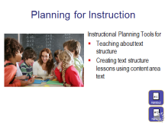
Handout #10 can be used after this module to help you plan two types of informational text structure lessons. The first planning tool on page 1 can be used for designing initial instruction in each of the common text structures based on what you have learned in this module. It includes using the three research-based strategies, other key considerations like selecting the appropriate texts to use, and follow-up activities for student practice.

The second tool, on page 2 of that same handout, is designed to help you plan reading lessons around your content-area materials that include using informational text structure knowledge as a strategy for improving comprehension. Remember, students will need repeated exposure to this practice of using text structure to help them comprehend what they read before they understand it completely and it becomes a reading skill they automatically apply on their own.

Handout #4, which includes the templates for each of the common text structures, should be helpful as you plan for both kinds of instruction.

Slide 35

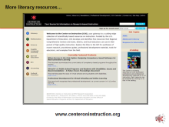
There is a second module in this Informational Text Structure series that provides professional development for 6th through 12th grade teachers. It too is available on the COI website. Look for…
Informational Text Structure: Using Knowledge of Text Structure to Improve Comprehension in Grades 6-12

For those viewing both modules, note that much of the same information is included in both modules because it applies to all grade levels. The differentiation between the two modules occurs in the activities and examples that make them applicable to the grade band addressed in the module.

Also, be sure to visit the Center on Instruction (COI) website to find additional resources that can support all schools with their improvement efforts.

COI offers materials to support:

- leadership,
- improving literacy instruction,
- professional development, and
- implementing college- and career-ready standards, including the Common Core State Standards.

Slide 36

That concludes today’s module. Thank you for your time and attention!

It has been a pleasure to share information about text structure instruction with you.
Remember to review the “Module 1 Handouts, Resources, and References” document that lists references and resources for additional sources of information to assist you in learning about and planning for teaching students to use text structure knowledge to improve their comprehension.

