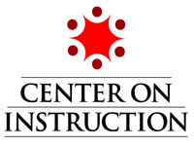

AGENDA

Virtual Working Meeting
Fostering Collaboration Between General and Special Educators Within an RTI Framework
Thursday, January 14, 2010 - 1:00 – 3:00 ET

Meeting Purpose: To learn about collaboration theory/research, apply knowledge to the area of education collaboration, discuss relevance toward work with SEAs, and, together, develop recommendations for SEAs to help foster effective collaboration between general and special education at the district and school levels.

Meeting Outcome: Our goal by the end of the virtual working meeting is to have developed a list of recommendations for SEAs focused on how effective collaboration between general and special education (at the local level) can be fostered at the state level.

1:00 – 1:10 Welcome

1:10 – 1:20 Introductions and Relevance to RCC Work

1:20 – 1:50 Presentation of Collaboration Research/Theory with Supporting Examples

1:50 – 2:30 Discussion: Relevance to work with states
- How is this useful for states?
- What kind of guidance do states need in this area?

2:30 – 2:45 Development of recommendations for SEAs (full consensus of group)

2:45 – 3:00 Wrap-up and Next Steps

